1. Write a program to depict the usage of the Lambda expression.
2. Write a program using the StringJoiner with example.
3. Write a program to depict the Optional class.
4. Show case the usage of for Each()
5. Write a program to showcase the usage of streams and method references.

1.

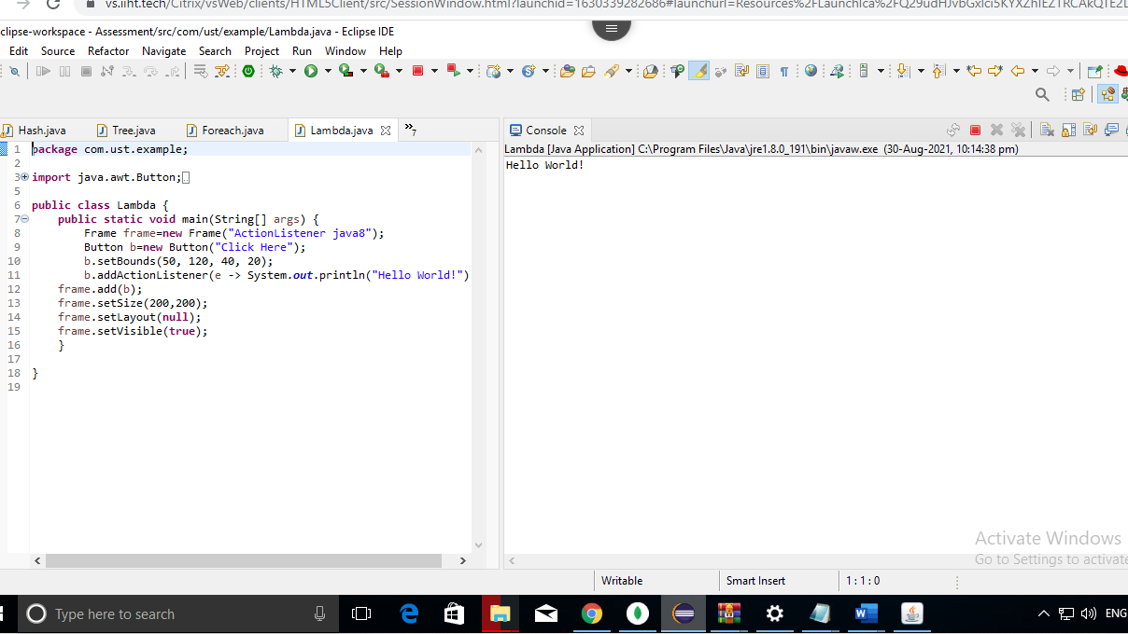



2.

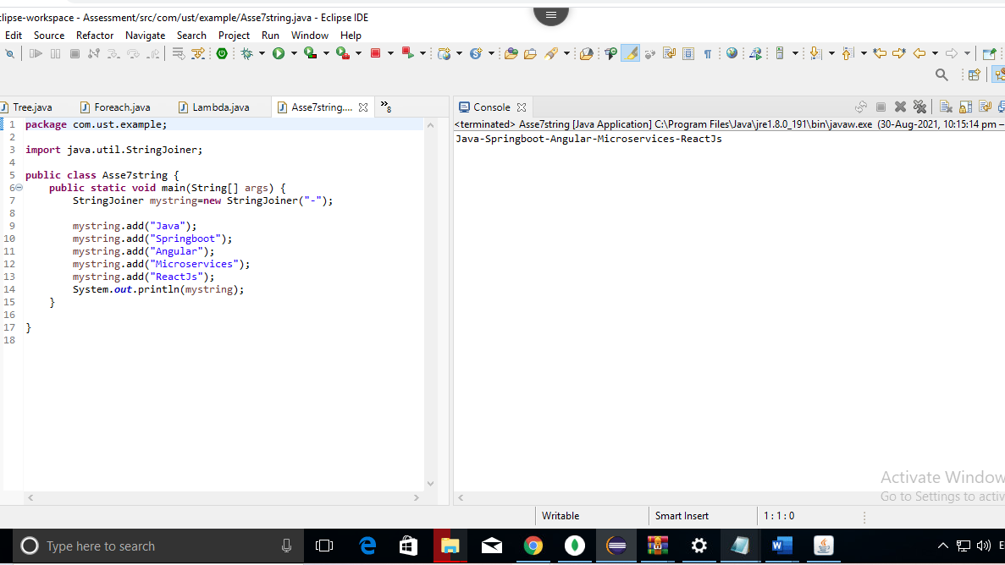



3.

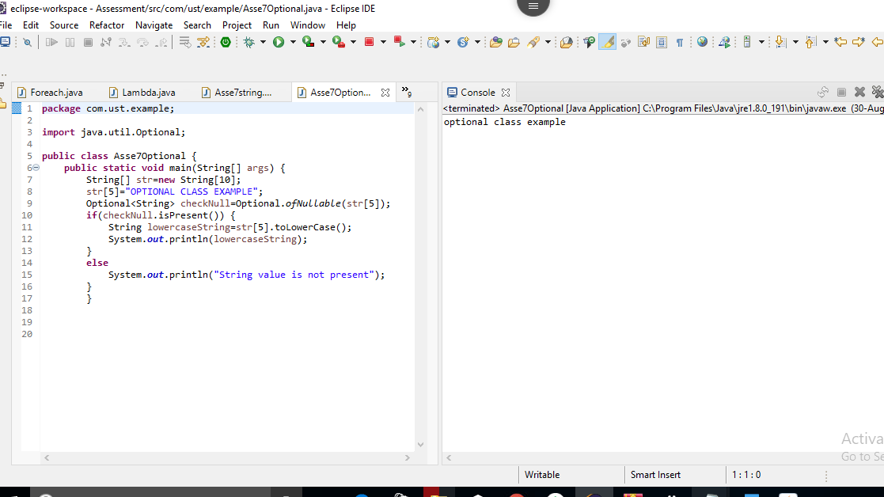



4.

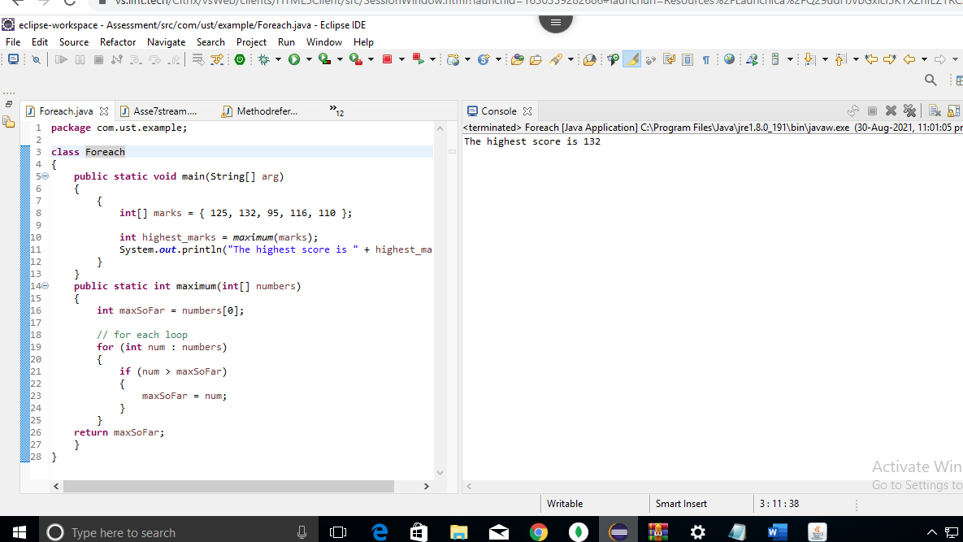



5.

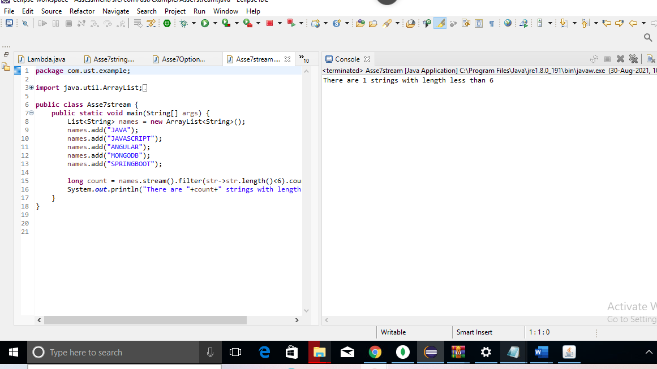



5.

